

**THE ORIGINS OF COMMUNAL ROOSTING BEHAVIOR IN BIRDS**

MSc. research proposal

Submitted by Sandra Cuadros

Supervised by Dr. Michael Noonan

Committee Members

Dr. Adam Ford, Dr. Autumn-Lynn Harrison, & Dr. Karen Hodges

Department of Biology

University of British Columbia Okanagan

October 2023

**Contents**

**Chapter 1: Movement ecology and wildlife foraging behavior** 2

**Chapter 2: Sharing is caring - The evolution of communal roosting behavior in birds** 16

**Chapter 3: The origins of ballistic motion** 20

**Chapter 5: Size matters: The Andean Condor – A peculiar case study** 29

**Chapter 6: Progress to date and Project timeline** 30

**Bibliography** 31



# **Chapter 1: Movement ecology and wildlife foraging behavior**

*Movement ecology and bird foraging behavior*

Despite long-standing interest in the factors that shape animal foraging behavior, it is still poorly understood how internal traits and external conditions jointly shape avian foraging movement (Mallon et al. 2020). Specifically, bird foraging behavior has been through direct observations. Because such methods are highly time-consuming, these studies have addressed the foraging behavior of specific taxa only (e.g., Smith et al. 2012), but research done on overarching questions aimed at unravelling the underpinning drivers of avian foraging ecology - especially across taxa - is not.

With the advance of tracking technology, however, different approaches can be used to make inferences on foraging behavior. For example, in mammals GPS data have been used to determine foraging based on velocities of movement (see Owen-Smith et al. 2012). Furthermore, using long-term data allows us to make predictions of important feeding grounds, especially for territorial species. Another study done with storks (*Ciconia ciconia*) confer information on the feeding areas during their life cycle and estimated the frequency of landfill use by the studied populations (Flack et al. 2016) using tracking data. Alternatively, a research paper on Andean Condors by Perrig et al. (2020) used GPS locations to identify probable foraging areas based on distance from roosting sites, velocity values and time of the day. There is a need to generate foundations on the types of movement associated to foraging behavior, especially given that the data are becoming more readily available.

Though individuals have many needs beyond nutrition (e.g., finding reproductive partners, sleeping, etc.), foraging is likely a key aspect of movement given that energy acquisition is essential for all heterotrophic species, which ultimately drives all other life processes. Hence, foraging ecology might be crucial to understand the mechanisms underpinning animal behavior. Given the vital importance of foraging, I will focus on my thesis on this aspect of ecology. In this opening chapter, I aim to review the current state of knowledge on potential drivers affecting foraging behavior of birds, and possible gaps that remain to be addressed to guide my work.

*Predictability of resources and foraging behavior*

To defend a feeding territory implies that there are benefits of doing so, one of them being energetic rewards (Ord 2021). Hence, it is expected that individuals with higher energetic demands (e.g., apex predators) will be more territorial than species in lower trophic guilds, all else being equal. Species with very specific niches and scarce or scattered food availability will also be more prone to defend territories because competition for these resources is likely to be stronger. As such, the greater the diet breadth of species, the less territorial they would be. However, when resources are unpredictable in the landscape, defending a feeding territory is no longer reasonable, and this is the case for many scavengers. Many scavenger species are large in size (vultures, ravens) which translates to high energetic demands, and yet they rely on unpredictable food patches, which naturally, cannot lead to territorial behavior (Grant 1993). Interestingly, many scavenger species forage in groups, leading to wonder if there are any benefits to this social behavior given the nature of their unpredictable food sources.

*Social structure and foraging behavior*

Evidence of social learning is growing across the animal kingdom (Aikens et al. 2022) with several studies looking at social behavior during migration. The benefits of social behavior, however, do not apply to migrating species alone. It has been discussed in the literature that one possible benefit from breeding in colonies is enhanced efficiency in exploiting an unevenly distributed food supply (Fisher 1954), which is supported by findings in Brewer’s Blackbird *Euphagus cyanocephalus* (Horn 1968). In addition, there is evidence to suggest that non-breeding sites like communal roosts do indeed act as information centers where individuals share information on foraging sites (Ward & Zahavi 1973, Wright et al. 2003). Thus, the sociality of communal roosting can be correlated to dispersion for foraging (Ward & Zahavi 1973), Here, vultures are an interesting system for several reasons. First, their unique feeding habits, since they are the only terrestrial vertebrate that is an obligate carrion consumer (van Overveld et al. 2020), second, because both New World Vultures and Old World Vultures – two independent lineages- converged to similar foraging habits (Van Overveld et al. 2022), and third, most- if not all- vulture species present some degree of social behavior with shared communal roosts among individuals.

*Memory and foraging behavior*

To navigate the landscape successfully, animals use cues in their environments like odor, sound, location and attributes in the landscape to guide their movement (e.g., Berberi et al. 2023). The process of acquiring this information, processing it and use it to make decisions is referred to as learning (Dukas, 2017,), and the term used for information retention is called memory (Rolls, 2014). This acquisition of knowledge is then used to evaluate whether to execute specific actions. For instance, an individual may decide whether or not to access a foraging area based on an assessment of the costs and benefits of doing so. Repeating this process and assessing the decision based on these costs or benefits suggest a learning process. Only recently has the field of movement ecology increased consideration of learning as part of animal decision-making when navigating the landscape (Fagan et al., 2013). For example, a study in blue whales showed that they rely highly on memory for migration and foraging areas (Abrahms et al. 2019). It is therefore reasonable to suggest that foraging is partially driven by learning processes as well. A classic example is that of feeding stations for vultures in Africa and Europe. For many vulture species that are in peril, supplementary feeding stations have been implemented to reduce poisoning threats. Once a group of individuals finds a feeding station, they will come back to use it frequently, given that the food is reliably there. This is a clear example of a memory process in foraging behavior. However, in a more complex scenario, with natural food availability, learning processes may function differently as food sources are usually scattered in the landscape, thus, animals might need to remember not one but many potential feeding grounds. One question arises, though: how does memory affect foraging efficiency for those species that feed on unpredictable food sources? If the food cannot be predicted, is memory all that relevant in finding them? Here, it can be argued that for scavengers that exhibit communal roosting behavior, short-term memory plays a role when finding and then sharing information with other individuals. Exploring the relationship between these two variables could open the door for further research questions in terms of the role of communal roosting in foraging success of a population, which ultimately has conservation implications.

*The unique nature of avian foraging ecology*

A relevant question remains unanswered – why are birds an interesting study system to answer the research questions here proposed? The answer has both ecological and pragmatic rationales. First, this behavior has been widely observed in birds (as opposed to other taxa where the behavior is not as persistent). Accordingly, many species of birds forage in groups, either by hunting or scavenging together, with this feature being more frequently seen among some groups in particular (e.g., corvids, vultures). Among the discussed benefits of sociality in the literature, a common consensus is that when doing so, individuals can be more efficient at finding food sources, which is the focus of this research. Although there are a few hypotheses to understand the origin of CRB, it is in birds where the behavior is more persistent across different groups (e.g., taxonomic groups, trophic levels, types of foraging). Thus, this group provides a comprehensive dataset to test and tease apart these hypotheses.

From a pragmatic perspective, there are extensive datasets existing for birds and systematized data. These reasons provide a unique opportunity to answer my proposed research questions and identify trends at the taxa level. Furthermore, if this idea can be further tested with movement data, at the moment birds are the taxa with more tracking data and for longer periods.

**Thesis aims and structure**

The overall aim of my thesis is to discuss drivers of communal roosting behavior and the potential implications on foraging efficiency in land birds.

*Chapter 1* will include a literature review on movement ecology of wildlife, with particular focus on bird foraging behavior. *Chapter 2* will be focused on understanding variables that affect the prevalence of communal roosting behavior (CRB) in birds. *Chapter 3* will use the previous chapters to highlight the value of sociality for foraging efficiency through the lens of Andean Condor (*Vultur gryphus*) conservation. *Chapter 4* describes the project timeline as well as my progress to date.

# **Chapter 2: Sharing is caring - The evolution of communal roosting behavior in birds**

**Introduction**

[**https://www.publish.csiro.au/book/7130#preview**](https://www.publish.csiro.au/book/7130#preview)

**Key word: local enhancement**

**file:///C:/Users/sandracd/Downloads/1312102.pdf**

**Thoughts as I am reading:**

**Could communal roosting be more frequent in less predictable landscapes (eg more natural?) versus more stable (human-dominated, that have carrion more available) in condors or other scavengers? Can we test this with movement data?**

Communal roosts are aggregations of unrelated individuals (either con- or heterospecific) that spend the resting period (either diurnal or nocturnal) together (Laughlin et al. 2014). This behavior is striking given the apparent little benefits of sharing space and resources with unrelated individuals. Yet, it is seen in species across many taxa, including fish (Clough and Ladle 1997), mammals (Kunz, 1982) and birds (Eiserer 1984). The frequency and diverse range of species in which communal roosting occurs suggest that it has evolved independently on numerous occasions, and that there should be an underlying mechanism, or set therefore, that support(s) this behavior.

It has been argued that these roosts are sites where naïve individuals can potentially exchange information with more experienced individuals on the location of food sources. This concept is formalized by Ward and Zahavi (1973) via the Information Center Hypothesis (ICH). Some prerequisites have been proposed by Mock (1988) to successfully test the ICH. First, *site fidelity*: individuals commute from specific roost sites to a recently detected carcass. Second, *differential success*: individuals differ in the information they have regarding food locations a given moment. In other words, there are informed and naïve individuals. Third, *signal transfer*: informed individuals may be identified by others through reliable physical (e.g., visual cues) or behavioral signals, either intentionally or inadvertently. This will allow for uninformed individuals to follow informed individuals. Fourth, *tolerance:* food resources are typically larger than the feeding capacity of a single individual, leading to satiation. Hence, information on location of food sources has little costs for the informed individual. Lastly, it is assumed that the cost of being a follower has an overall positive payoff than exploring for food individually. If the ICH holds true, individuals that exhibit communal roosting behavior are expected to have increased foraging efficiency than those who do not (e.g., Harel et al. 2017). Undoubtedly, this would be beneficial for scavengers given the high competition for their pulsed food resources (Van Overveld et al. 2022).

In an attempt to answer this question, the drivers for the communal roosting behavior in 201 bird species were tested by Beauchamp (1999), and his findings suggested that increased foraging efficiency was the most likely cause for communal roosting behavior. Other studies on specific species support this idea (Dermody et al. 2011). The conclusions on the aforementioned studies altogether open a new avenue for research to test this hypothesis in several other systems. Although the ICH has been well studied conceptually, these ideas have not been tested yet on a broader taxonomic scale after Beauchamp’s study, and a general understanding of the factors influencing avian communal roosting behaviour remain unknown. Using the comparative method, this chapter will focus on answering the following research question: what biological variables affect the prevalence of communal roosting behavior in landbirds?

**Methods**

Here, I will use the comparative method to explore the evolutionary relationship between physiological and biological traits and the communal roosting behavior in landbirds (*sensu* Felsenstein 1985) comprising roughly 8373 species. The traits selected for the analysis are body mass (kg) and diet breadth following Beauchamp (1999), and others like defensibility of food sources, Hand-wing index (HWI), trophic guild and memory. A rationale as to why these potential explanatory variables were selected follows:

* Dietary breadth: Specifically, I expect that species with low diet breadth may obtain less benefits from CRB as for low values (niche specialists), sharing information on food sources might not benefit the individuals; conversely, they might benefit from defending the resource. For species with high values of diet breadth (niche generalists), however, they do benefit from sharing as their resource might not be as limited. Data on diet breadth will be retrieved from the literature on number of prey items. The main database will be Birds of the World (hereon BOW, <https://birdsoftheworld.org/bow/home>) but complementary information will be obtained through search engines.
* Prey size to predator size ratio: The defensibility of the food source is expected to reduce CRB given that if food patches can be defended, there are no benefits of sharing with conspecifics (*sensu* Grant 1993). To test for defensibility of food sources, I will use a ratio between prey size and predator size (henceforth termed the ‘defensibility ratio’). The smaller the ratio, the more defensible the food source is expected to be.
* Trophic guild: Trophic guild follows a comparable pattern, where scavengers are expected to rely more on CRB given the unpredictable nature of their food sources (Harel et al. 2017). Data from Trophic guild will be obtained through AVONET, an online database for all bird species. Complementary information will be used to adjust for these categories where pertains.
* Hand-wing Index (HWI): Hand-wing index is a metric of dispersal ability in birds (Arango et al., 2022) and therefore it indicates the capacity of a species to scout looking for food sources. Where HWI is high, CRB may bring more benefits as they might access food location over broader areas that can be then accessed by others through information sharing (Buckley 1997). Hand-wing Index values will be obtained through AVONET.
* Memory: Memory was chosen as, for species to share information, memory on the location of the food source is required to be later passed on (G Hernández-Montero et al. 2020). To test for this variable, relative brain size (absolute brain size in relation to body mass) following van Overbeld et al. (2022).
* Mass: Finally, mass was selected *a priori* from a larger pool of co-variates to reduce correlation between parameters. For instance, body mass, average lifespan and clutch size can potentially have an effect on communal roosting behavior given that larger, long-lived species tend to rely on information sharing to meet their greater energetic demands. Mass values will be obtained through AVONET.

The species selected to test my hypothesis will be core land birds (Brusatte et al. 2015) as aquatic species are likely to follow significantly different foraging strategies (e.g., nesting and roosting sites are not differentiated which challenges disentangling the reason for roosting behavior). Communal roosting behavior will be classified as a Bernoulli variable where 0 is non-roosting behavior, and 1 is complete roosting behavior. Species for which this behavior is not properly documented will be classified as data deficient, and excluded from the analysis. Phylogenetic relationships between species will be obtained from <https://vertlife.org/>.

Figure 2.1 below shows the anticipated relationships between avian communal roosting behavior and the variables tested.

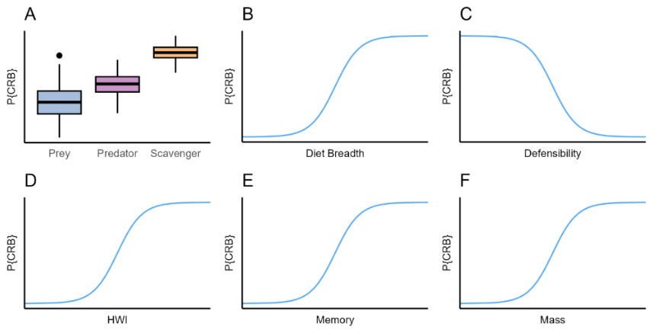

Figure 2.1. Anticipated relationships between the selected biological traits and the probability of Communal Roosting Behavior (p{CRB}). A) Trophic guild and Probability of Communal Roosting Behavior, where it will be considerably more probable in scavengers than in other trophic guilds. B-F show continuous biological variables and the expected relationship with P{CRB}.

*Statistical analyses*

The evolutionary relationship between communal roosting behavior (CRB) and will be modelled using Equation 1.

Eq. 1

$$CRB =β_{1}mass+ β_{2}Defensibility+β_{3}HWI+ β_{4}Trophic guild+β_{5}Memory+ β_{6}Diet breadth$$

Where CRB is the Communal Roosting Behavior, and $β$ is the regression coefficient that determines the relationship between the variables. The model will be fitted in R using the *brms* package using a binomial error distribution.

**Preliminary results**

A preliminary analysis conducted on 120 species of *corvidae* shows a positive correlation between HWI and mass and CRB (Fig. 2.2). In addition, trophic guild shows a clear pattern as well, with omnivores having a strong signal for communal roosting behavior (Fig. 2.2).

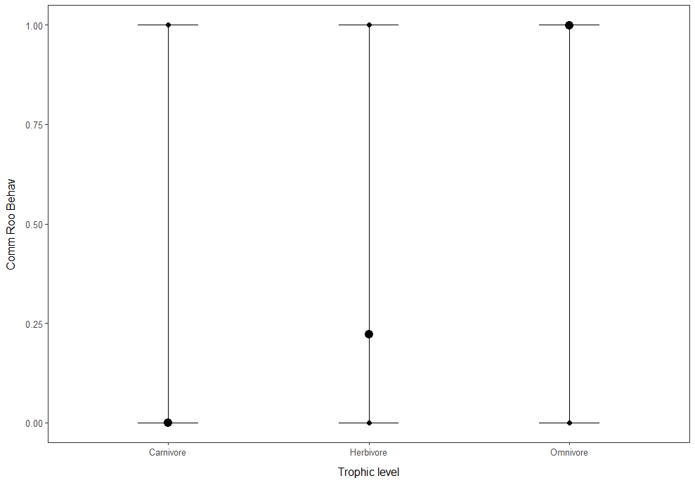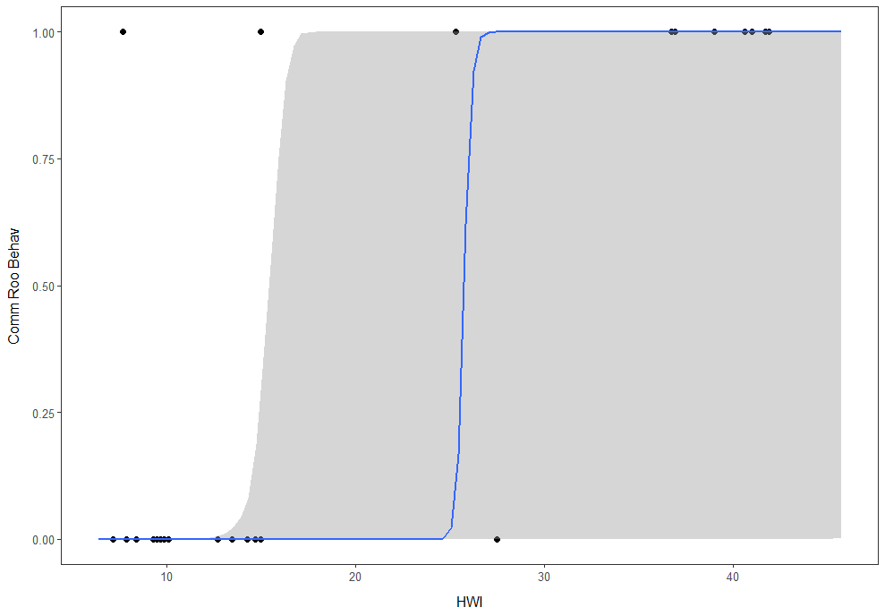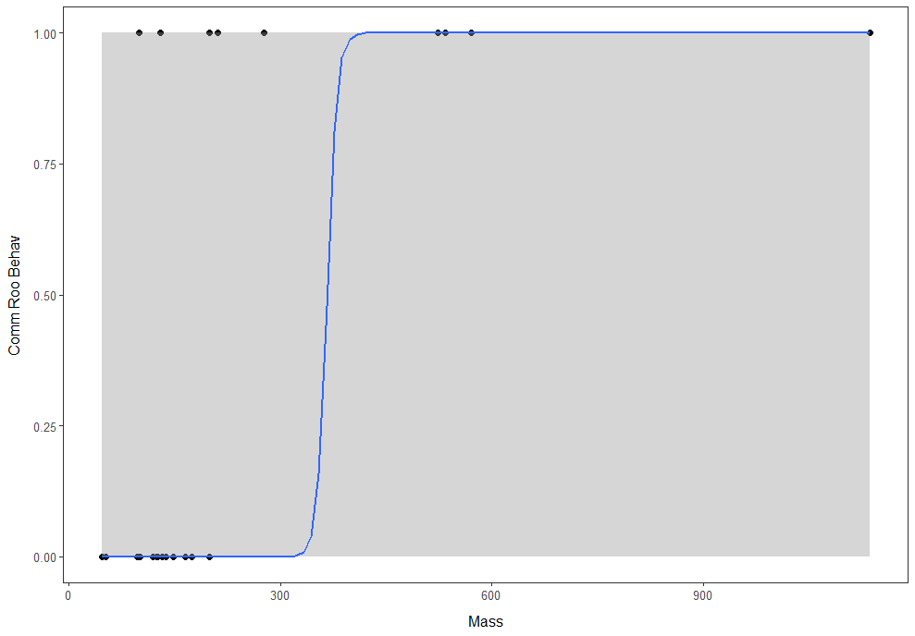

Figure 2.2. Communal Roosting behavior and biological variables

**Discussion and future work**

Preliminary results show patterns in line to those proposed by my hypothesis (Fig. 2.1). However, further analysis will be needed to add more detail on trophic guild (e.g., obligate and facultative scavengers included), as well as more bird species. Other variables still remain to be tested and finally variables modelled to determine which ones have a stronger effect on CRB.

# **Bibliography**

Abrahms, B., Hazen, E. L., Aikens, E. O., Savoca, M. S., Goldbogen, J. A., Bograd, S. J., ... & Mate, B. R. (2019). Memory and resource tracking drive blue whale migrations. Proceedings of the National Academy of Sciences, 116(12), 5582-5587.

Aikens, E. O., Bontekoe, I. D., Blumenstiel, L., Schlicksupp, A., & Flack, A. (2022). Viewing animal migration through a social lens. *Trends in Ecology & Evolution*, *37*(11), 985–996.

Beauchamp, G. (1999). The evolution of communal roosting in birds: Origin and secondary losses. *Behavioral Ecology*, *10*(6), 675–687.

Benhamou, S. (2014). Of scales and stationarity in animal movements. *Ecology Letters*, *17*(3), 261–272.

Berberi, I., Miller, E. T., & Dakin, R. (2023). The effect of sociality on competitive interactions among birds. *Proceedings of the Royal Society B: Biological Sciences*, *290*(1994), 20221894.

Brusatte, S. L., O’Connor, J. K., & Jarvis, E. D. (2015). The Origin and Diversification of Birds. *Current Biology*, *25*(19), R888–R898.

Buckley, N. J. (1997). Experimental tests of the information-center hypothesis with black vultures (Coragyps atratus) and turkey vultures (Cathartes aura ). *Behavioral Ecology and Sociobiology*, *41*(4), 267–279.

Burt, W. H. (1943). Territoriality and Home Range Concepts as Applied to Mammals. *Journal of Mammalogy*, *24*(3), 346.

Clough S, Ladle M. 1997. Diel migrations and site fidelity in a stream dwelling cyprinid, Leuciscus leuciscus. J Fish Biol. 50:1117–1119.

Dermody, B. J., Tanner, C. J., & Jackson, A. L. (2011). The Evolutionary Pathway to Obligate Scavenging in Gyps Vultures. *PLoS ONE*, *6*(9), e24635.

Dukas, R. (2017). Cognitive innovations and the evolutionary biology of expertise. *Philosophical Transactions of the Royal Society B: Biological Sciences*, *372*(1735), 20160427.

Eiserer, L. A. (1984). Communal roosting in birds. Bird Behavior, 5(2-3), 61–80.

Felsenstein, J. (1985). Phylogenies and the Comparative Method. The American Naturalist, 125(1), 1–15. Fisher, J.B. (1954). Evolution and bird sociality. *Evolution as a Process*, 71-83.

Flack, A., Fiedler, W., Blas, J., Pokrovsky, I., Kaatz, M., Mitropolsky, M., Aghababyan, K., Fakriadis, I., Makrigianni, E., Jerzak, L., Azafzaf, H., Feltrup-Azafzaf, C., Rotics, S., Mokotjomela, T. M., Nathan, R., & Wikelski, M. (2016). Costs of migratory decisions: A comparison across eight white stork populations. *Science Advances*, *2*(1), e1500931.

Fortin, D., Beyer, H. L., Boyce, M. S., Smith, D. W., Duchesne, T., & Mao, J. S. (2005). Wolves influence elk movements: behavior shapes a trophic cascade in Yellowstone Pational Park. *Ecology*, *86*(5), 1320–1330.

Grant, J. W. A. (1993). Whether or not to defend? The influence of resource distribution. *Marine Behaviour and Physiology*, *23*(1–4), 137–153.

Gregory, S. C., Haegen, W. M. V., Chang, W. Y., & West, S. D. (2010). Nest Site Selection by Western Gray Squirrels at Their Northern Range Terminus. *The Journal of Wildlife Management*, *74*(1), 18–25.

Guigueno, M. F., Shoji, A., Elliott, K. H., & Aris-Brosou, S. (2019). Flight costs in volant vertebrates: A phylogenetically-controlled meta-analysis of birds and bats. *Comparative Biochemistry and Physiology Part A: Molecular & Integrative Physiology*, *235*, 193–201.

Harel, R., Spiegel, O., Getz, W. M., & Nathan, R. (2017). Social foraging and individual consistency in following behaviour: Testing the information centre hypothesis in free-ranging vultures. *Proceedings of the Royal Society B: Biological Sciences*, *284*(1852), 20162654.

Hayward, M. W., & Slotow, R. (2009). Temporal Partitioning of Activity in Large African Carnivores: Tests of Multiple Hypotheses. *South African Journal of Wildlife Research*, *39*(2), 109–125.

Hengeveld, G. M. (2007). *Moving to eat: Animal foraging movements in a heterogeneous environment*.

Hernández-Montero, J. R., Reusch, C., Simon, R., Schöner, C. R., & Kerth, G. (2020). Free-ranging bats combine three different cognitive processes for roost localization. *Oecologia*, *192*(4), 979–988.

Hertel, A. G., Efrat, R., Reznikov, K., Sapir, N., Berger-Tal, O., & Mueller, T. (2023). Time constraints may pace the ontogeny of movement behaviour. *Proceedings of the Royal Society B: Biological Sciences*, *290*(1996), 20222429.

Horn, H. S. (1968). The Adaptive Significance of Colonial Nesting in the Brewer’s Blackbird (Euphagus Cyanocephalus). *Ecology*, *49*(4), 682–694.

Houston, D., G. M. Kirwan, D. A. Christie, and C. J. Sharpe (2020). Andean Condor (*Vultur gryphus*). Version 1.0. In Birds of the World (J. del Hoyo, A. Elliott, J. Sargatal, D. A. Christie, and E. de Juana, Editors). Cornell Lab of Ornithology, Ithaca, NY, USA.

Johnson DH (1980) The comparison of usage and availability measurements for evaluating resource preference. Ecology 61:65–71

Johnson, M. D. (2007). Measuring Habitat Quality: A Review. *The Condor*, *109*(3), 489–504.

Kano, F., Sasaki, T., & Biro, D. (2021). Collective attention in navigating homing pigeons: Group size effect and individual differences. *Animal Behaviour*, *180*, 63–80.

Kays, R., Crofoot, M. C., Jetz, W., & Wikelski, M. (2015). Terrestrial animal tracking as an eye on life and planet. *Science*, *348*(6240), aaa2478.

Kunz T, H. (1982). Roosting ecology of bats. In: Kunz TH, editor. Ecology of bats. New York: Plenum Press. p. 1–55.

Laughlin, A. J., Sheldon, D. R., Winkler, D. W., & Taylor, C. M. (2014). Behavioral drivers of communal roosting in a songbird: A combined theoretical and empirical approach. *Behavioral Ecology*, *25*(4), 734–743.

Mallon, J. M., Tucker, M. A., Beard, A., Bierregaard, R. O., Bildstein, K. L., Böhning‐Gaese, K., Brzorad, J. N., Buechley, E. R., Bustamante, J., Carrapato, C., Castillo‐Guerrero, J. A., Clingham, E., Desholm, M., DeSorbo, C. R., Domenech, R., Douglas, H., Duriez, O., Enggist, P., Farwig, N., … Fagan, W. F. (2020). Diurnal timing of nonmigratory movement by birds: The importance of foraging spatial scales. *Journal of Avian Biology*, *51*(12), jav.02612.

Mock, D. W., Lamey, T. C., & Thompson, D. B. A. (1988). Falsifiability and the Information Centre Hypothesis. *Ornis Scandinavica*, *19*(3), 231.

Mueller, T., & Fagan, W. F. (2008). Search and navigation in dynamic environments – from individual behaviors to population distributions. *Oikos*, *117*(5), 654–664.

Nathan, R., Getz, W. M., Revilla, E., Holyoak, M., Kadmon, R., Saltz, D., & Smouse, P. E. (2008). A movement ecology paradigm for unifying organismal movement research. *Proceedings of the National Academy of Sciences*, *105*(49), 19052–19059.

Nauta, J., Khaluf, Y., & Simoens, P. (2020). Hybrid foraging in patchy environments using spatial memory. *Journal of The Royal Society Interface*, *17*(166), 20200026.

Nonacs, P., & Dill, L. M. (1993). Is Satisficing an Alternative to Optimal Foraging Theory? *Oikos*, *67*(2), 371.

Noonan, M. J., Martinez-Garcia, R., Fleming, C. H., De Figueiredo, B. G., Ali, A. H., Attias, N., Belant, J. L., Beyer, D. E., Berteaux, D., Bidner, L. R., Boone, R., Boutin, S., Brito, J., Brown, M., Carter, A., Castellanos, A., Castellanos, F. X., Chitwood, C., Darlington, S., … Calabrese, J. M. (2023). *The search behavior of terrestrial mammals* [Preprint]. Ecology

Nussbaumer, R., Schmid, B., Bauer, S., & Liechti, F. (2022). Favorable winds speed up bird migration in spring but not in autumn. *Ecology and Evolution*, *12*(8).

Ord, T. J. (2021). Costs of territoriality: A review of hypotheses, meta-analysis, and field study. *Oecologia*, *197*(3), 615–631.

Owen-Smith, N., Goodall, V., & Fatti, P. (2012). Applying mixture models to derive activity states of large herbivores from movement rates obtained using GPS telemetry. *Wildlife Research*, *39*(5), 452.

Perrig, P. L., Lambertucci, S. A., Cruz, J., Alarcón, P. A. E., Plaza, P. I., Middleton, A. D., Blanco, G., Sánchez-Zapata, J. A., Donázar, J. A., & Pauli, J. N. (2020). Identifying conservation priority areas for the Andean condor in southern South America. *Biological Conservation*, *243*, 108494.

Pekarsky, S., Shohami, D., Horvitz, N., Bowie, R. C. K., Kamath, P. L., Markin, Y., Getz, W. M., & Nathan, R. (2023). *Cranes soar on thermal updrafts behind cold fronts as they migrate across the sea* [Preprint]. Ecology.

Pennycuick, C. J. (2008). Modelling the flying bird. Elsevier.Poessel, S. A., Brandt, J., Miller, T. A., & Katzner, T. E. (2018). Meteorological and environmental variables affect flight behaviour and decision-making of an obligate soaring bird, the California Condor *Gymnogyps californianus*. *Ibis*, *160*(1), 36–53.

Rolls, E. T. (2014). Emotion and decision-making explained: A précis. *Cortex*, *59*, 185–193.

Shipley, L. A., Spalinger, D. E., Gross, J. E., Hobbs, N. T., & Wunder, B. A. (1996). The Dynamics and Scaling of Foraging Velocity and Encounter Rate in Mammalian Herbivores. *Functional Ecology*, *10*(2), 234.

Smith, B. J., MacNulty, D. R., Stahler, D. R., Smith, D. W., & Avgar, T. (2023). Density‐dependent habitat selection alters drivers of population distribution in northern Yellowstone elk. *Ecology Letters*, *26*(2), 245–256.

Smith, R. V., Stafford, J. D., Yetter, A. P., Horath, M. M., Hine, C. S., & Hoover, J. P. (2012). Foraging Ecology of Fall-Migrating Shorebirds in the Illinois River Valley. *PLoS ONE*, *7*(9), e45121.

Southwood, T. R. E. (1977). Habitat, the Templet for Ecological Strategies? *The Journal of Animal Ecology*, *46*(2), 336.

Sutherland, W. J., Newton, I., & Green, R. (2004). *Bird Ecology and Conservation*. Oxford University Press.

Tobalske, B. W., Hedrick, T. L., Dial, K. P., & Biewener, A. A. (2003). Comparative power curves in bird flight. *Nature*, *421*(6921), 363–366.

Tucker, M. A., Alexandrou, O., Bierregaard Jr, R. O., Bildstein, K. L., Böhning‐Gaese, K., Bracis, C., ... & Mueller, T. (2019). Large birds travel farther in homogeneous environments. Global Ecology and Biogeography, 28(5), 576-587.

van Overveld T, Blanco G, Moleón M, Margalida A, Sanchez-Zapata JA, De la Riva M, Donázar JA (2020) Integration vulture sociality into conservation practice. Condor 122:duaa035

Van Overveld, T., Sol, D., Blanco, G., Margalida, A., De La Riva, M., & Donázar, J. A. (2022). Vultures as an overlooked model in cognitive ecology. *Animal Cognition*, *25*(3), 495–507.

Ward, P., & Zahavi, A. (1973). The importance of certain assemblages of birds as “information-centres” for food-finding. *Ibis*, *115*(4), 517–534.

Wright, J., Stone, R. E., & Brown, N. (2003). Communal roosts as structured information centres in the raven, Corvus corax. *Journal of Animal Ecology*, *72*(6), 1003–1014.

Zuberogoitia, I., González-Oreja, J. A., Martínez, J. E., Zabala, J., Gómez, I., & López-López, P. (2013). Foraging movements of Eurasian griffon vultures (Gyps fulvus): Implications for supplementary feeding management. *European Journal of Wildlife Research*, *59*(3), 421–429.